

In heart, InKitchen

Islombek Salimov U1610083

Islom Babaev U1610081

Laziza Nasridinova U1610124

Igor Tsoy U1610077

Vadim Kim U1610251

Khudyorkhon Mirjalolov U1610109

http://inkitchen.tw1.ru/

**Description**: InKitchen is an open-ended culinary blog where everyone can find a recipe for the soul. This is an open area for all who like to eat delicious food, as well as for those who like to cook. InKitchen gives all cook amateurs the opportunity to become professional chefs.

Our **customers** are ordinary people all over the world. They can be housewives, students, chefs or even business people. All you need is a fantasy, a gadget and a huge desire.

Since InKitchen is a non-profit organization we do not hire any employees. We ourselves are the administrators of the blog.

**Our team members:**

Islombek Salimov – the leader of the team and front-end developer. He has implemented all the html pages: main page, registration page, login page and etc.

Islom Babaev – back-end developer. He has implemented such functionalities as create post, delete post, layout managing, form inputs, and etc. using Laravel framework.

Laziza Nasridinova – head of ideas. She came up with the idea of the culinary blog, created the name of the blog, worked on the content of the blog, wrote the report.

Igor Tsoy – designer. He has created the whole design of the blog. Also created the landing page.

Vadim Kim – front-end developer. He did the input validation using JavaScript

Khudyorkhon Mirjalolov – editor. He worked with the content of the landing page, and with the database migrations and relations.

This is our landing page with the brief description of InKitchen blog and all the members of our team. Our team has used a Laravel php-based framework for processing the user requests. As we open our hosting, **inkitchen.tw1.ru**, we can see the main page, to which we are routed through about_us.blade.php. As soon as you click on the Get Started button, you will be transferred to the main page of the InKkitchen blog.

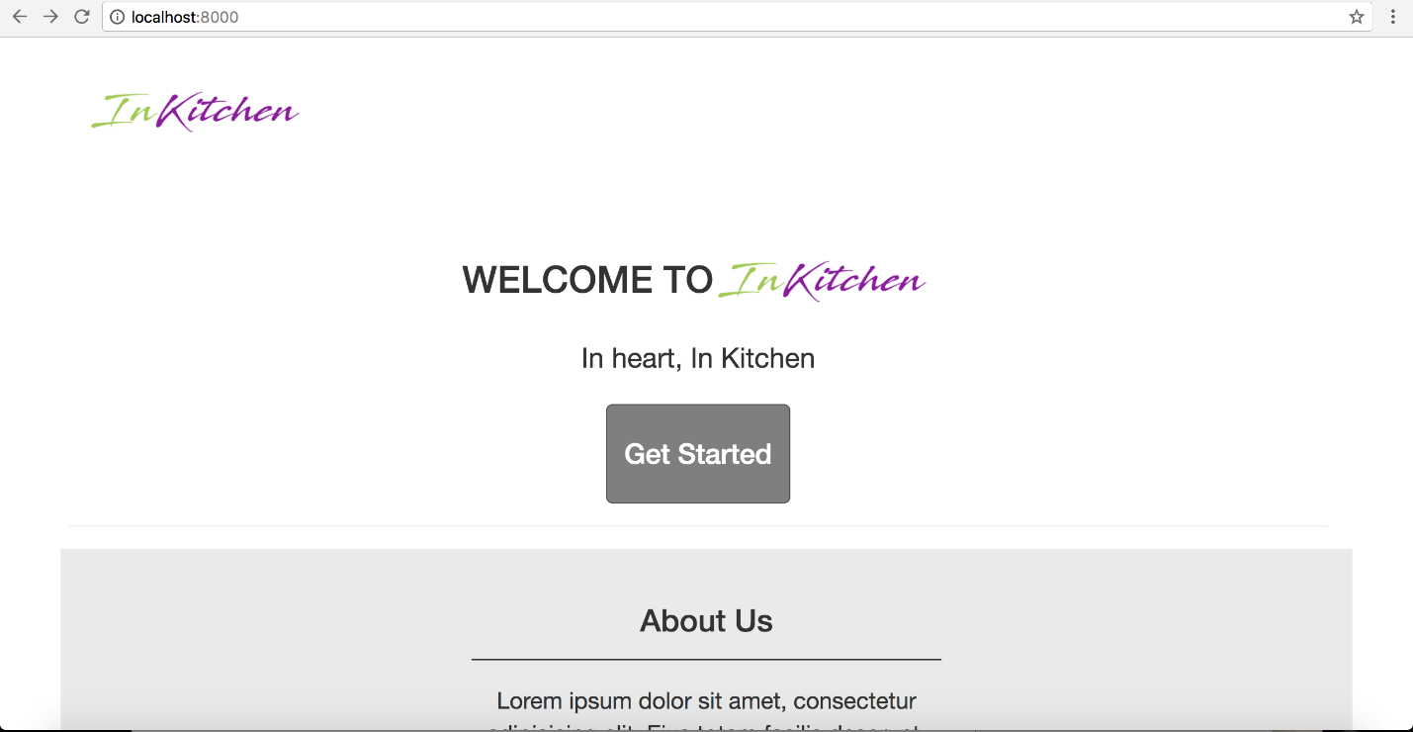

Thus, as we click the button we are direct to the index.blade.php and we start our journey to the world of cuisine. Here on the main page you can see the most popular recipes, and several categories.

This page is free to use for everyone, i.e. you can visit the page as a simple visitor without having additional functions.

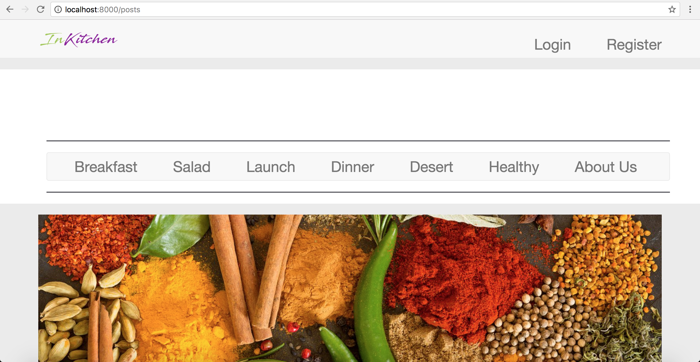

On the navigation bar we can see that we have our logo which directs to the main page and which is implemented via a simple routing. Furthermore, if the user is not authenticated, he will see the options 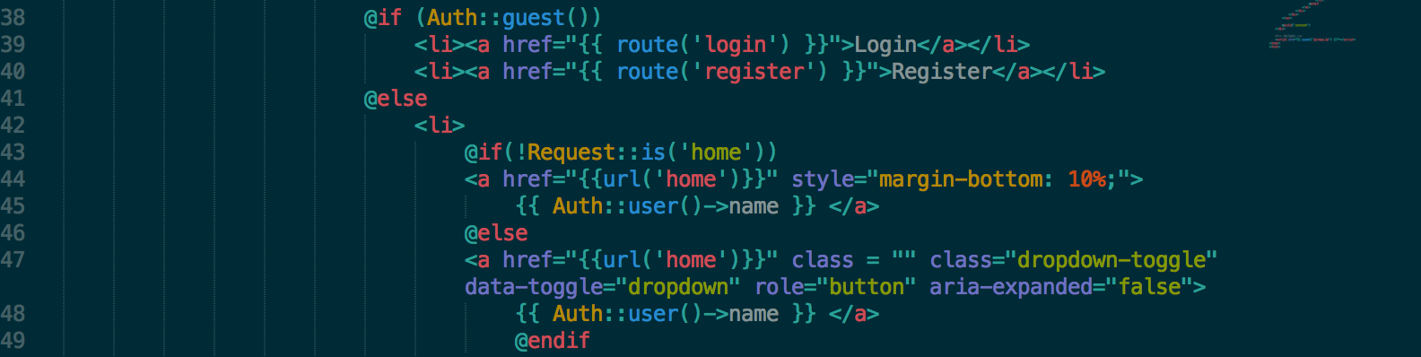to either login or register and if not, can go to its profile and see relevant posts created by this user.

If you have a desire to become a member of our blog, then in the upper right corner you can see the log in function. Click it! For the first time you need to register, for this press the registration button, which is located directly under the button Forgot the password.

Then you are automatically transferred to the registration page. Here you need to fill out the registration form. Enter your first name, last name, email address and set the password. After that submit the form.

Afterwards, we proceed to the basic Laravels registration page and register a user which is then stored in the database.!

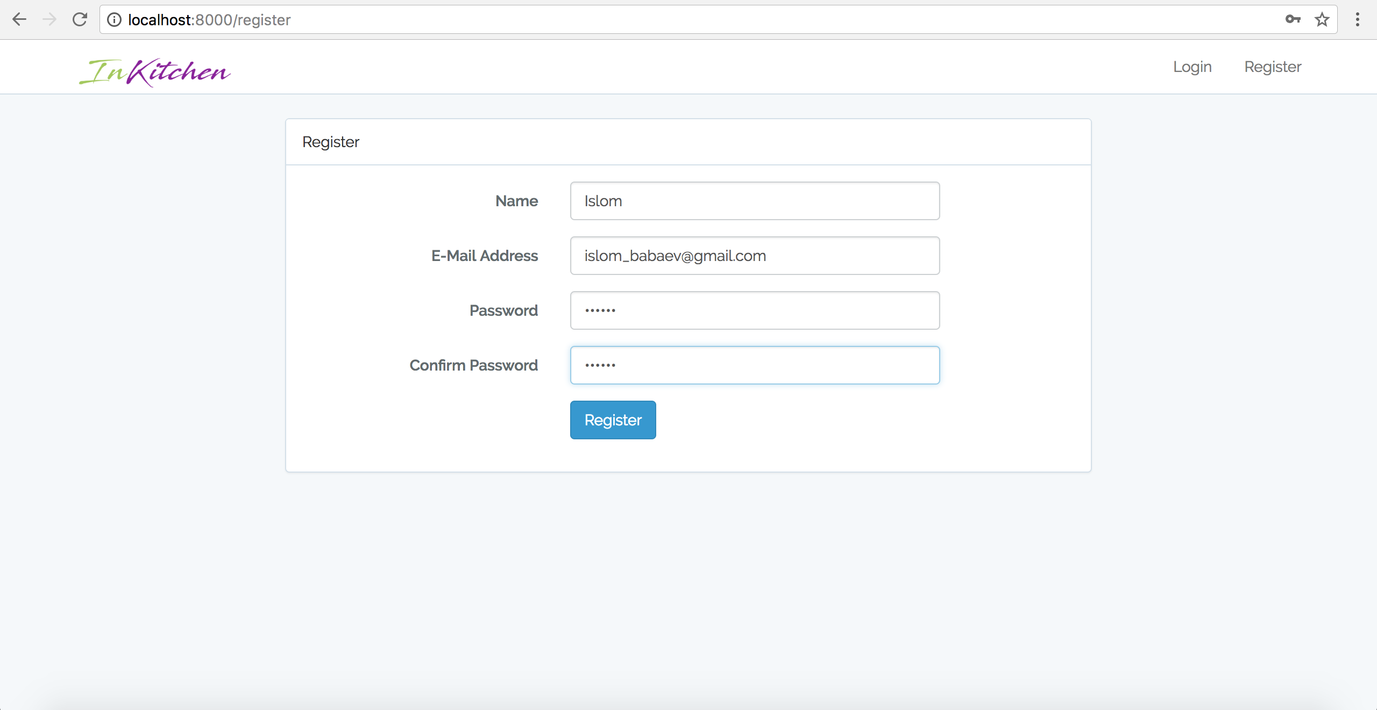

If you have already registered and visiting the blog as a user, clicking on the log in you need to enter your name and password.

As we register, we are directed to the /home page, which is a basic profile page with some functionality.

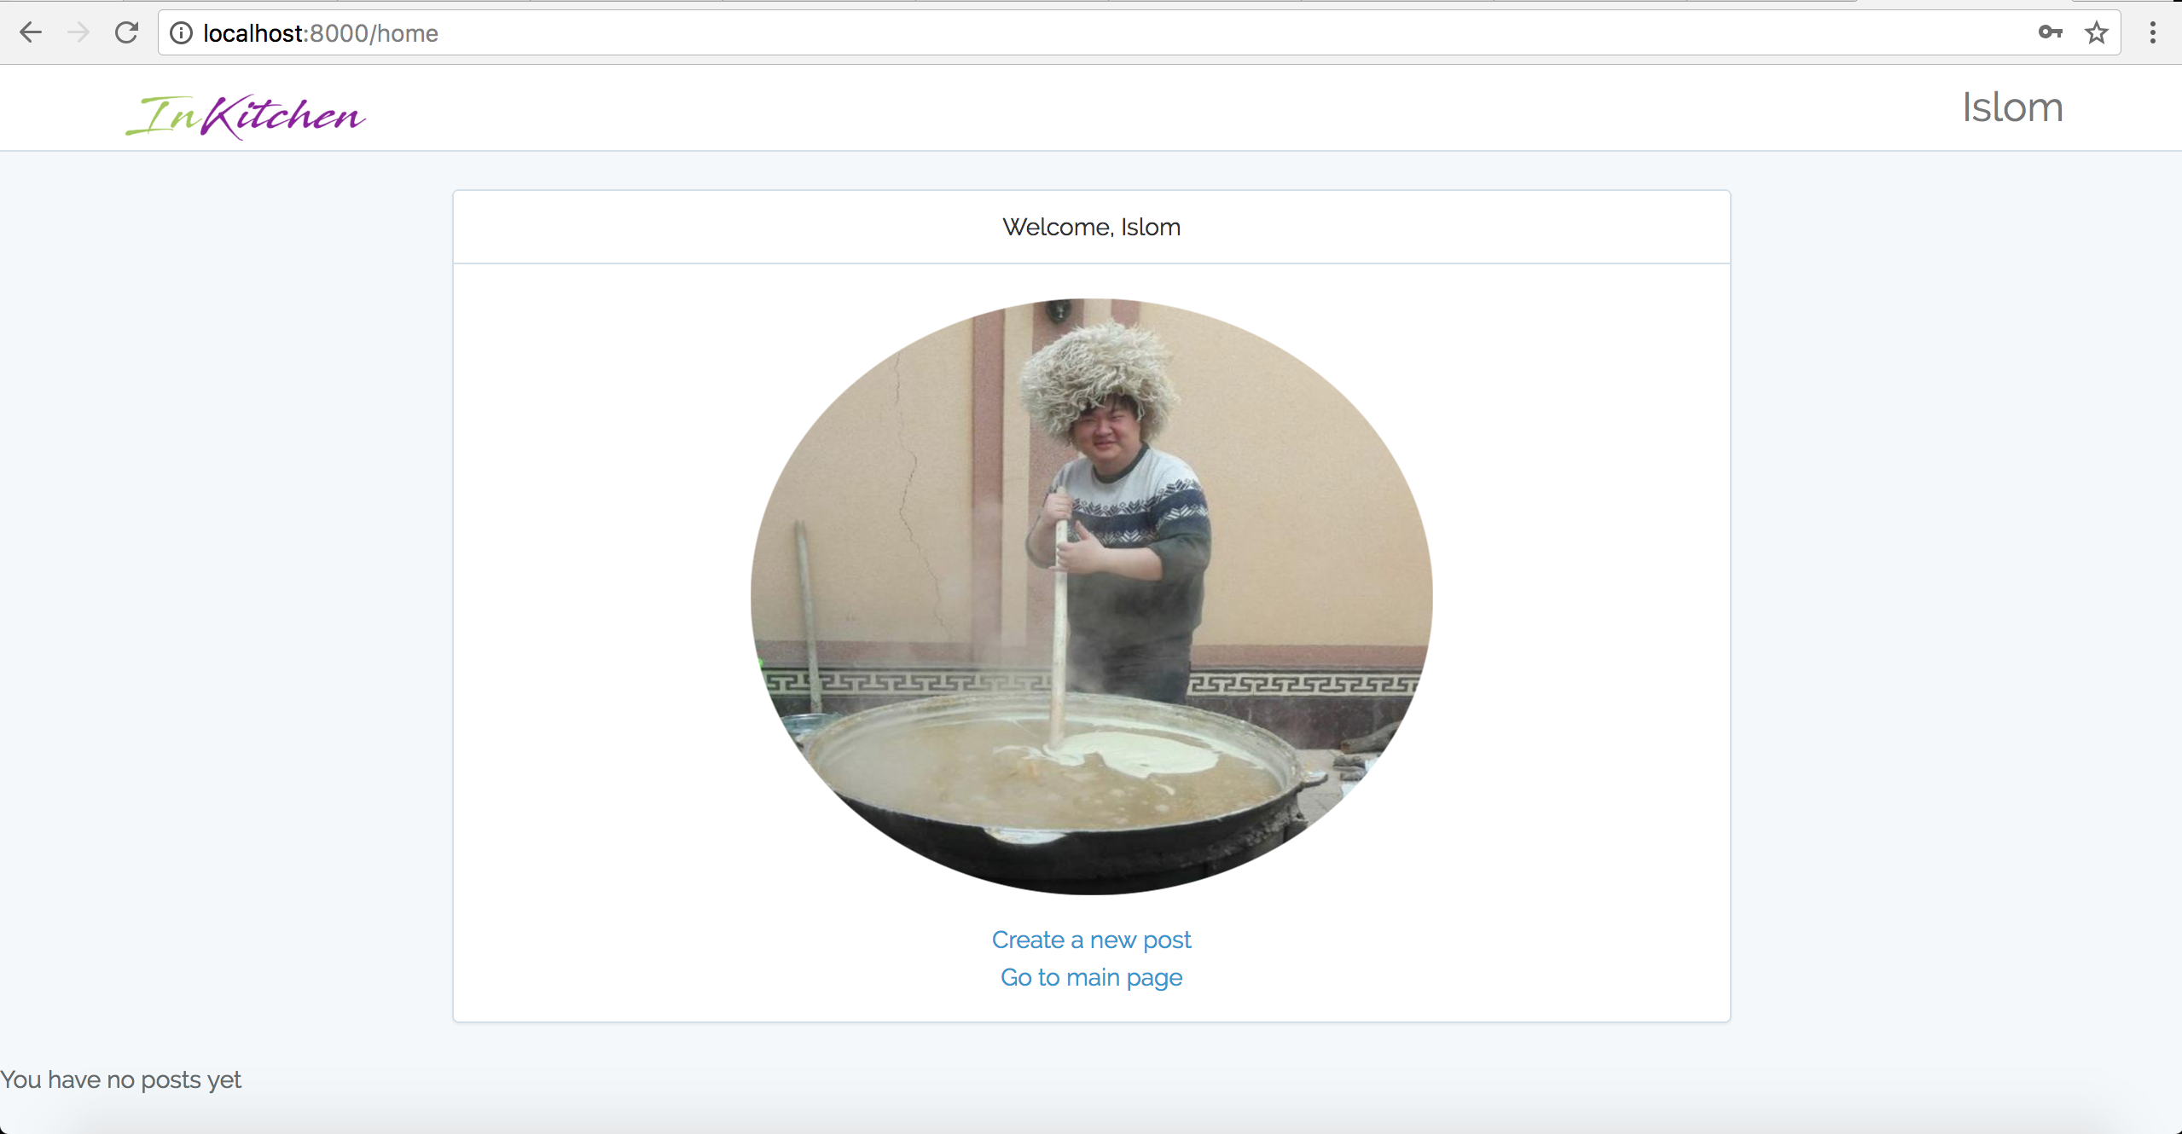When you entered the personal cabinet, you can see the function create a post. Clicking this button, you are transferred to next page. At the left bottom corner, we can see that we have no created posts and at the center we have a default avatar for all the users.

We have created a basic form to input the title of the receipt, its body (content) and an image. All these fields are set to require by default. If the post is successfully submitted to the server, it then will be 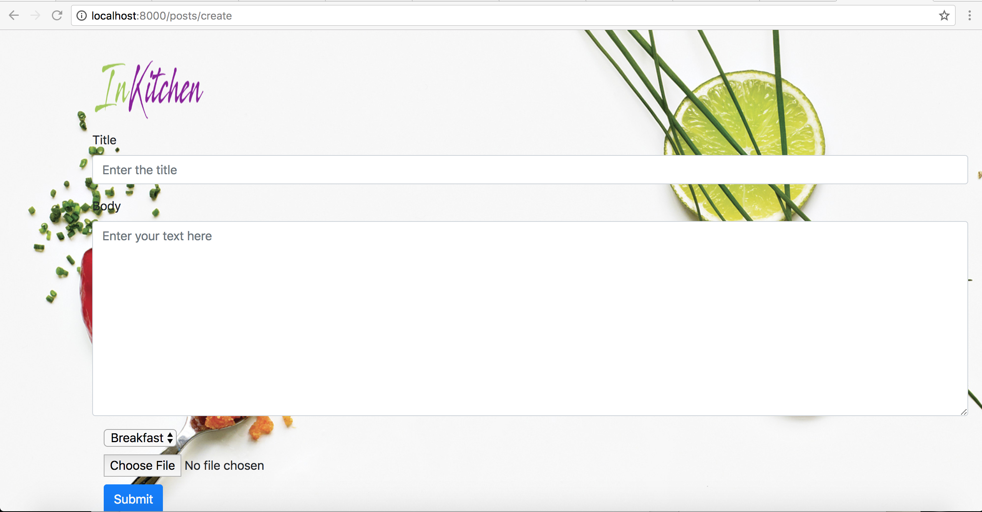displayed firstly in the page with categories and then in the relevant categories as well.

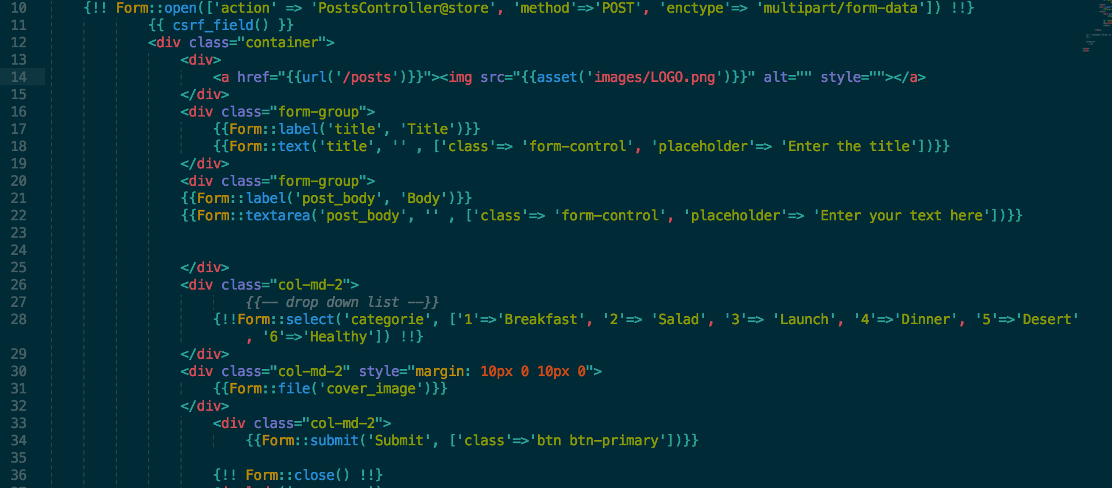The above code creates a simple form to input and we set the enctype to multipart/form-data so as to submit files to our database. The form creates a label for a title, textarea for a post boyd, a drop down list for a categories to be chosen and a button for submitting the file.

Proceeding to our controller, we validate all the input fields through a validate function. Subsequently, so as to make our file unique, we need to parse its filename by adding the _ (underscore) sign and a timestamp at when the file was submitted to the database. This, in turn, will eliminate all the chances for the files with a same name to overlap and cause logic error. However, if the image is not chosen by 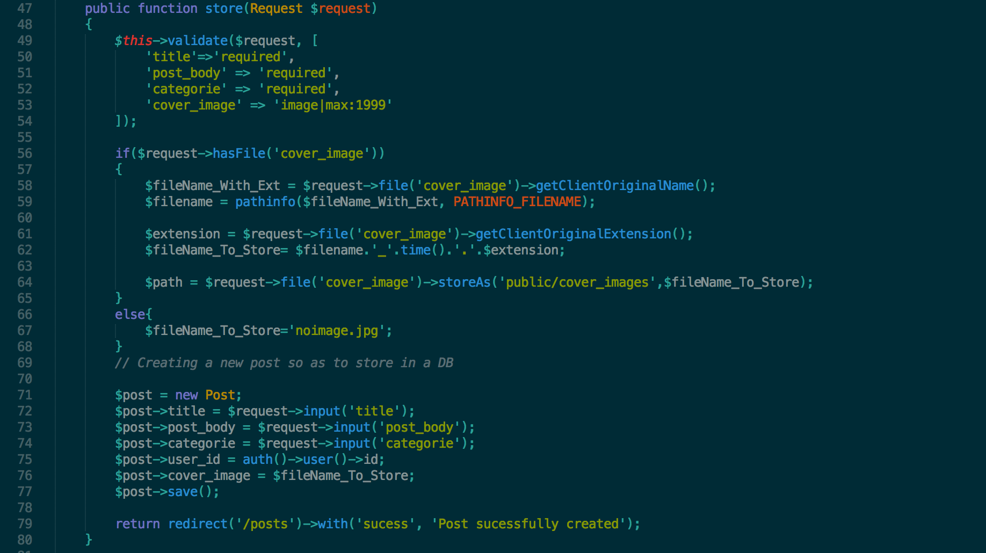the user, we have a default image for the post in our storage/public folder.

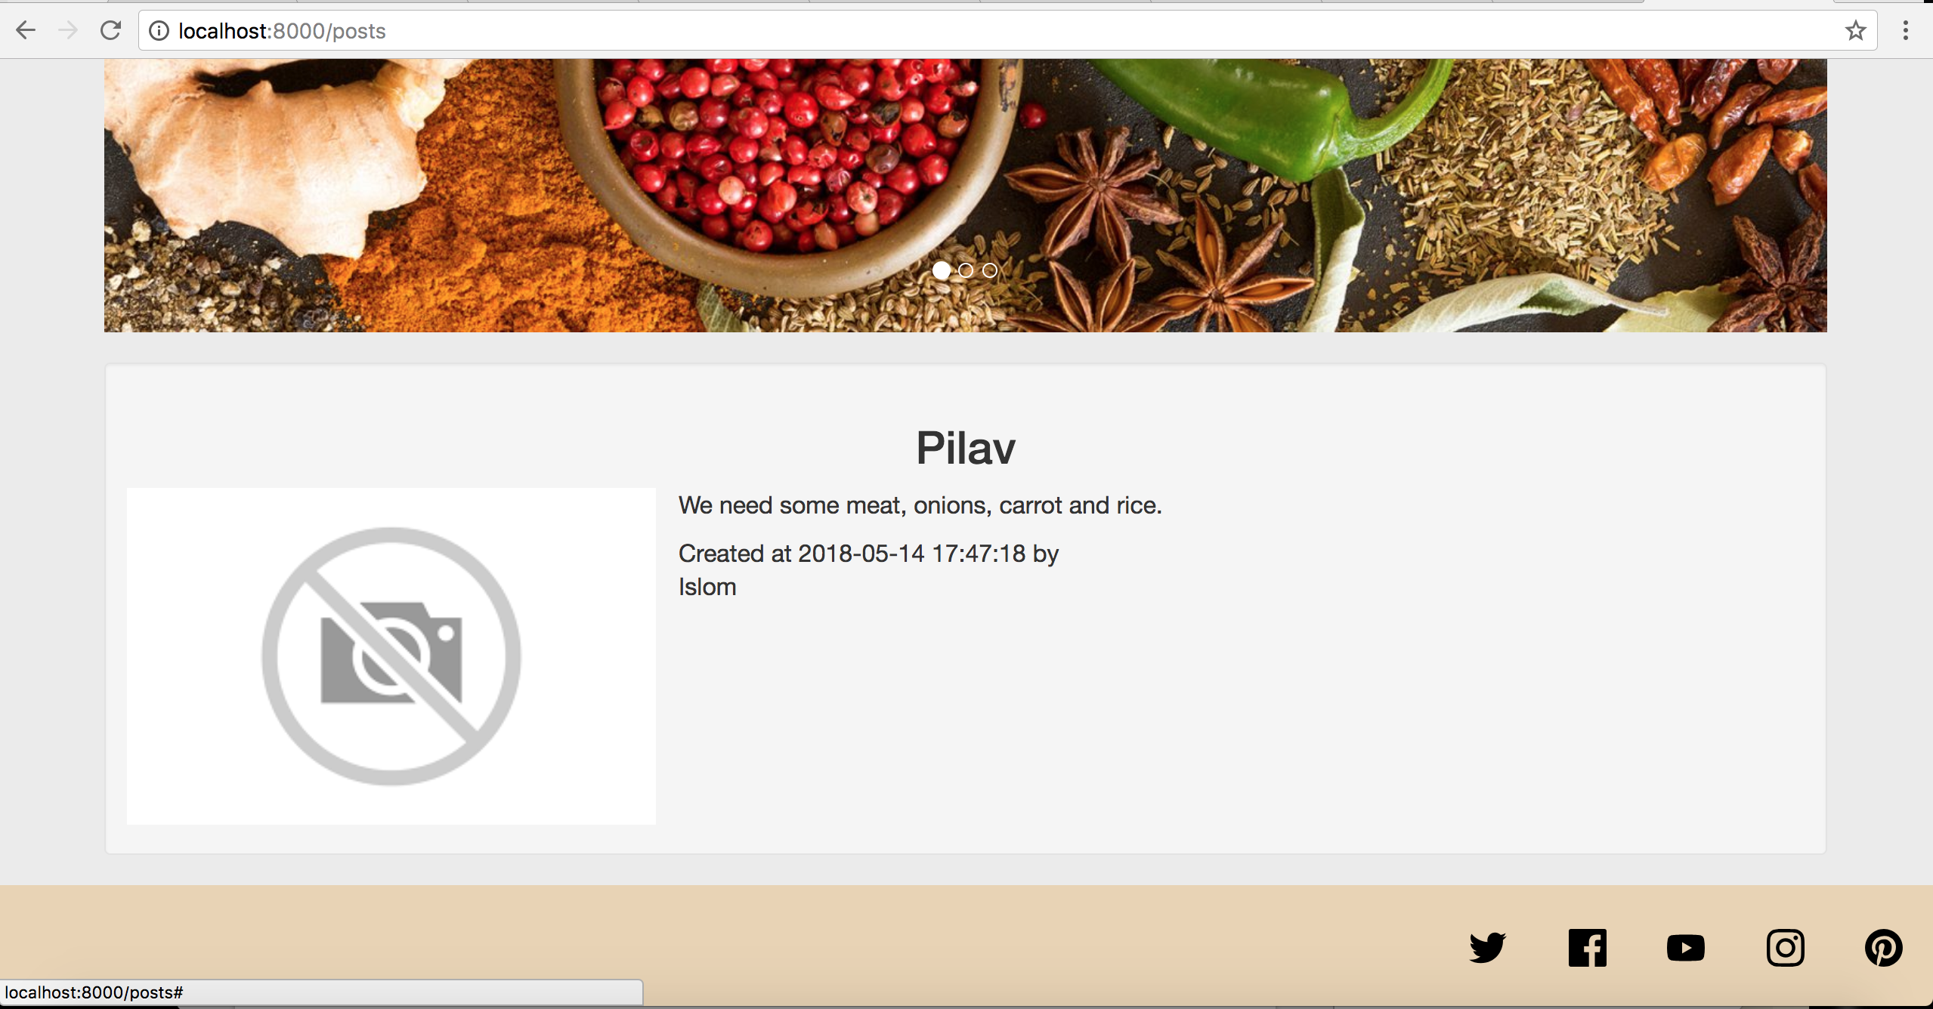 Moreover, we can see this post in our profile page as well.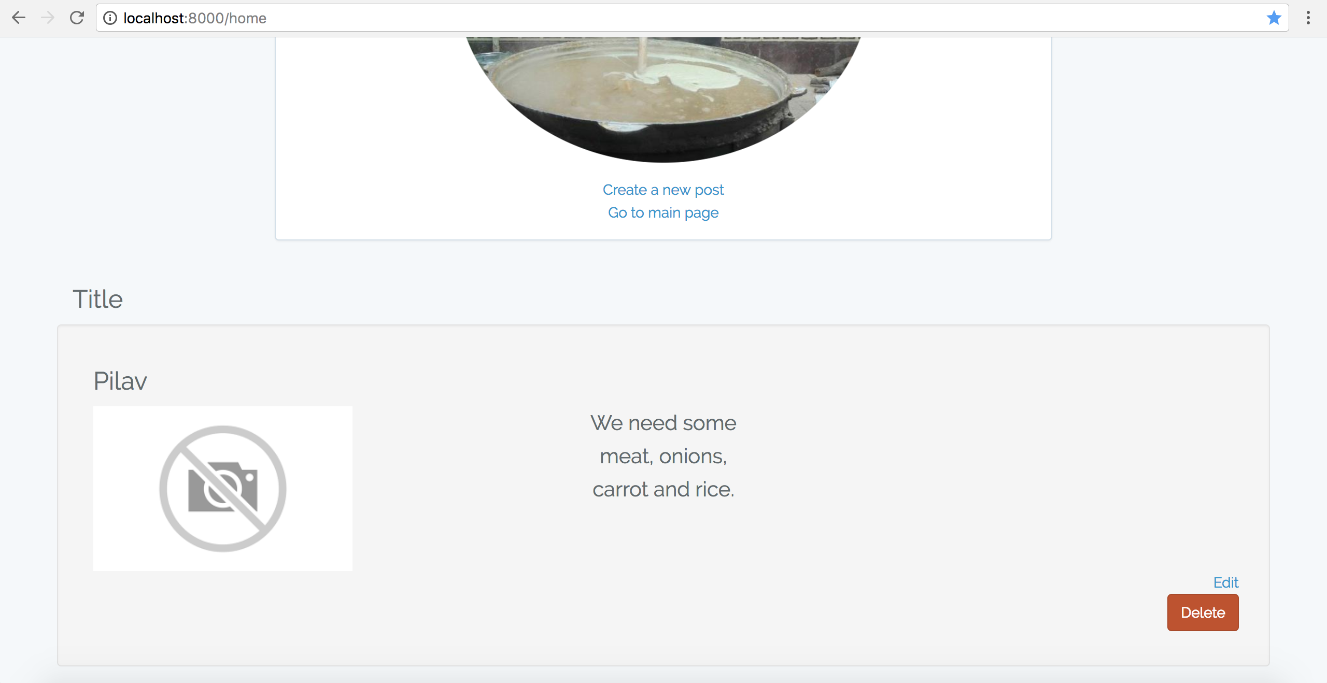

Since we have used the middleware for authenticating the user, the guest will not be able to see the post without being logged in or registered which can be viewed from the below screenshot.

Since we have passed the second parameter as an associative array, we allow the guest to see the index 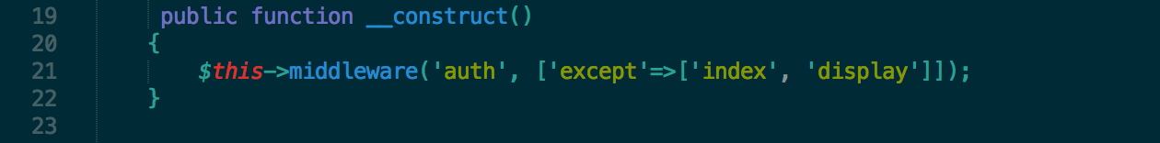page and the display pages. We verify the above mentioned information via following screenshot.

This would prevent guests from editing or deleting the posts or viewing them, which is logical.

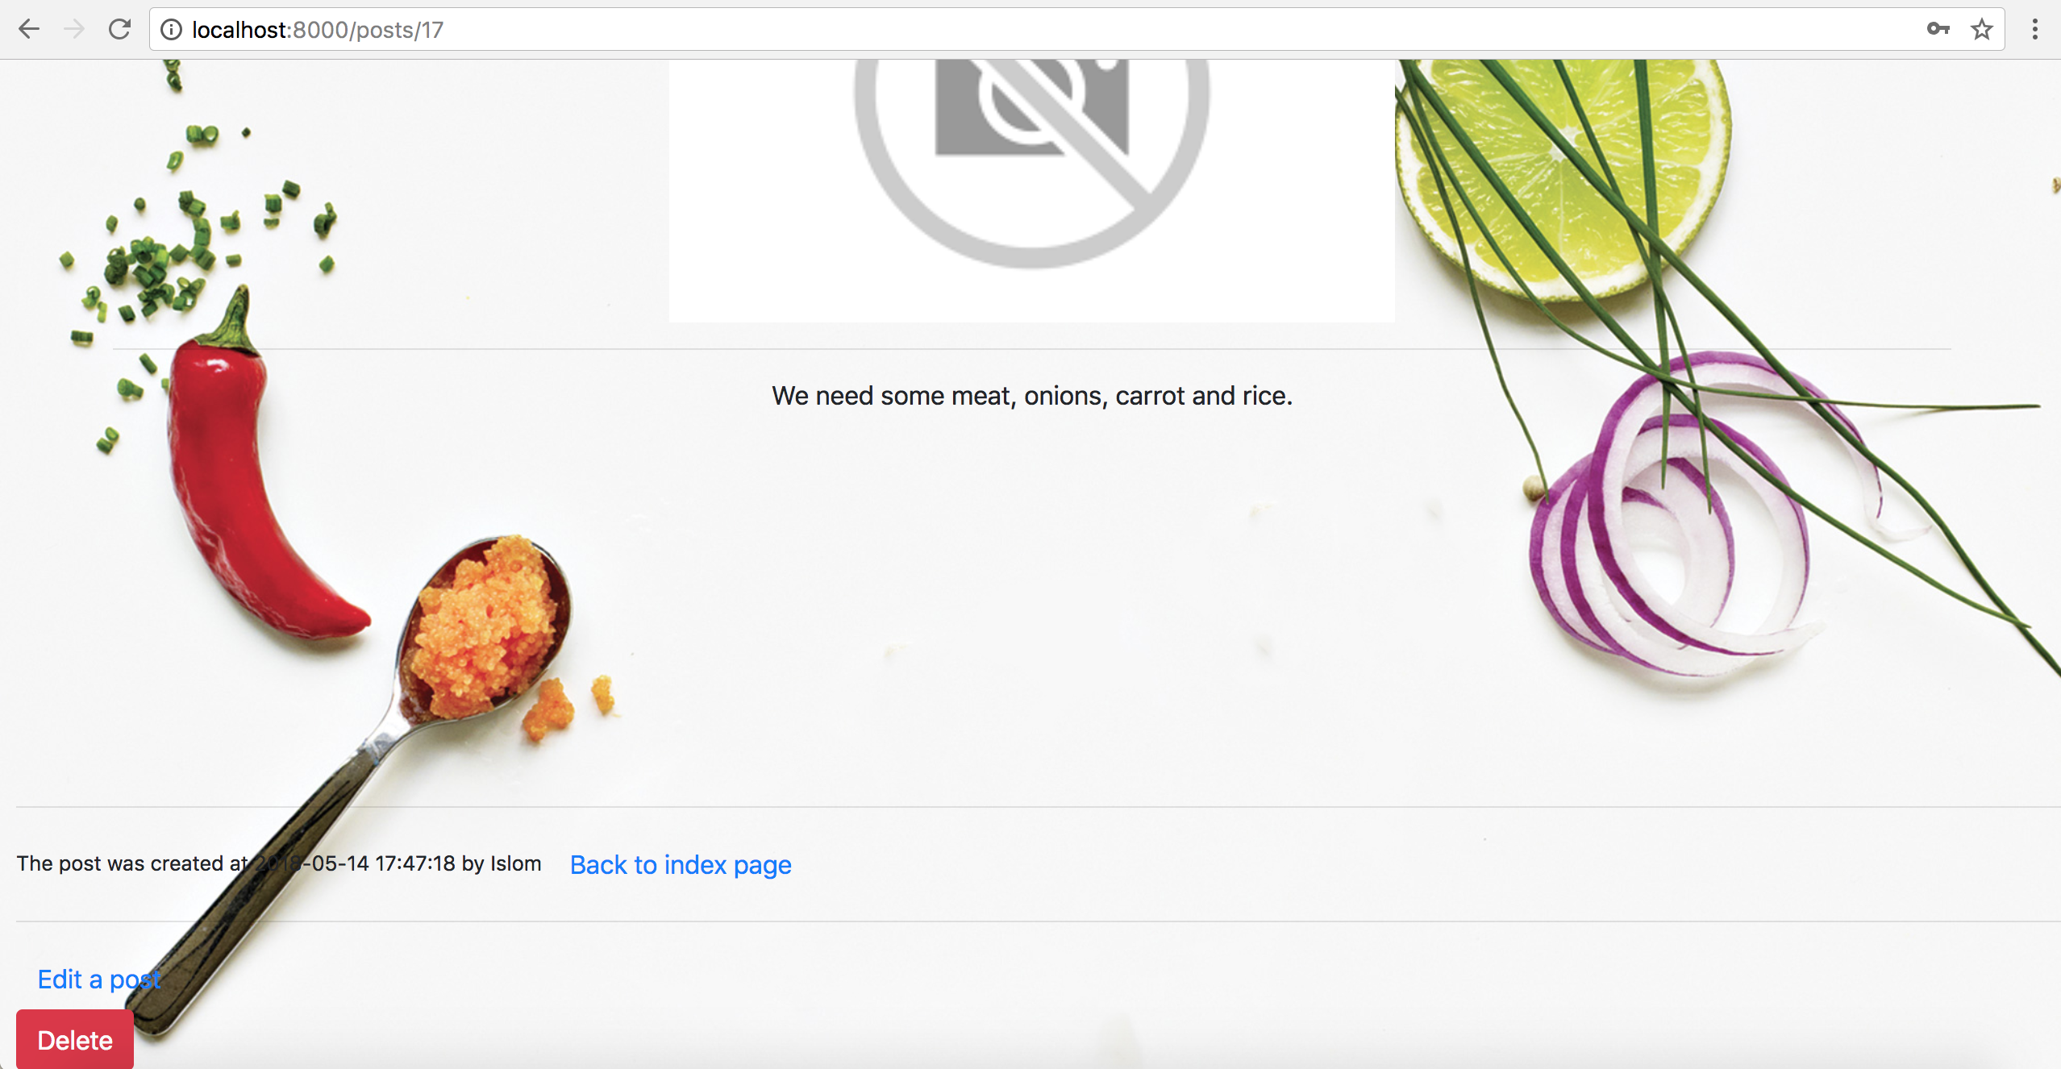We then proceed to the edit function, which is quite similar to that of a create function and so as to edit the post, we click the image and are redirected to the page of the post.